ITMD 455/555 Wk 4 Review Xml, Layouts, Java - solutions

1. What are some unique features using XML in Android?

2. Which of the following is the correct syntax to declare the XML version?

a. <?xml version="1.0"?> b. <xml version="1.0"> c. <?xml version=1.0?>

3. Is this a "well formed" XML document?

<?xmlversion="1.0"?>

<to>Tove</to>

<from>Jani</from>

<heading>Reminder</heading>

<body>Don't forget me this weekend!</body>

4. Is this a "well formed" XML document? Yes

<?xml version="1.0"?>

<note>

<to age="29">To Tommy</to>

<from>Jani</from>

</note>

5. True or false? XML elements cannot be empty.

6. Which is not a correct name for an XML element?

a. <NAME> b. <age> c. <first name> d. All 3 names are incorrect

7. True or false? XML attribute values must always be enclosed in quotes.

8. Create a getter function to return an arraylist string item named **fName**.

9. A thread can best be described as

|  |  |  |  |
| --- | --- | --- | --- |
| a. | A concurrent unit of execution | c. | That is allows for multitasking |
| b. | A single unit of execution | d. | That is can handle multiple executions |

10. The function call sleep(1000) stops a process for how long?

a. 1000 seconds b. 1 millisecond c. 1 second d. 60 seconds or 1 minute

11. What constraint is missing in View C below so the layout would actually appear as shown

to user?

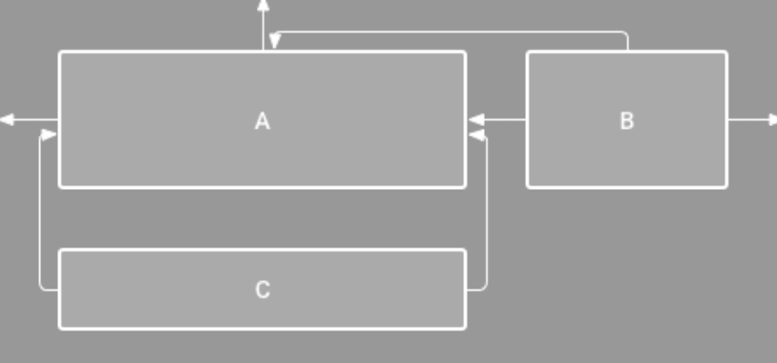

12. A(n) ____ is a container that can hold as many objects as needed.

a. emulator b. layout c. switch d. workspace

13. When you create a new Android project, the default object placed into the emulator window is a ____.

a. Button b. CheckBox control c. TextView control d. Volume control

14. To change the text displayed by a TextView control in its element XML, you change the ____________________ property.

15. When you import a package, you make all of the classes under that package available.

a. True b. False

16. A(n) ____ organizes layout components in relation to each other.

a. Extensible layout b. Graphical layout c. Linear layout d. Relative layout

17. ____ is not a valid measurement unit for text display.

a. dp b. dpi c. px d. sp

18. The set of resources available to an app is referenced by ____.

a. res b. R c. S d. V

19. A ____ is a triplet of three colors which encodes different colors.

|  |  |  |  |
| --- | --- | --- | --- |
| a. | controlled color code | c. | standard color encoding |
| b. | hexadecimal color code | d. | triple-coded color |

20. To refer to the elements of an array called “travel” in the manifest, the proper reference is android:text=“____”.

a. @+id/travel c. @travel

b. @+travel d. travel